Session 4:

Topic : Cross, Inner, Outer Joins with edge case of Conditional Statements

Students and Examinations
Ques 1: You are given:
(1) A list of students
(2) A list of subjects
An examinations table that records each time a student attended an exam (duplicates allowed)
Every student takes every subject, but the examinations table may have multiple entries per exam or none.
Your task:
Create a table showing for every student - subject pair, how many times they attended that subject’s exam.
Sort by student_id, then subject_name.
(Note :Output can be in Random Order)

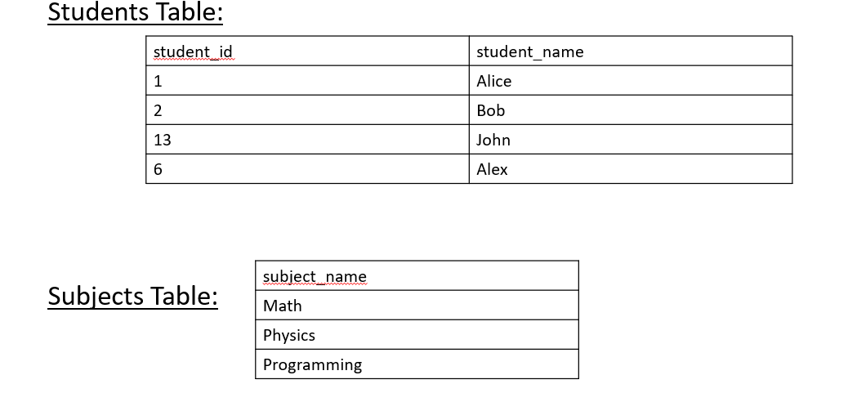
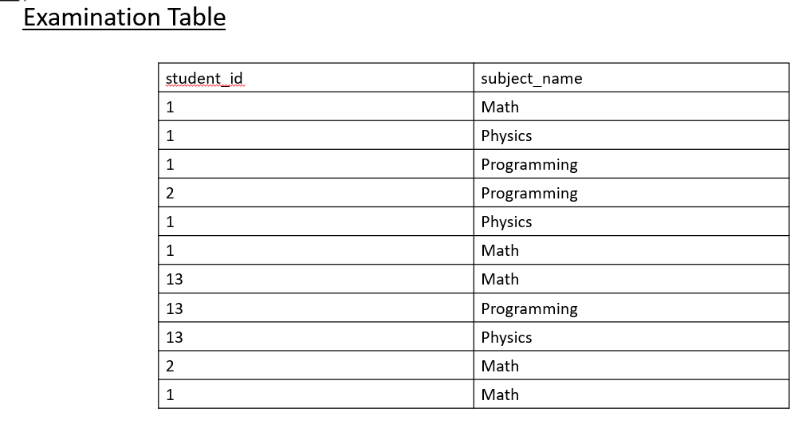

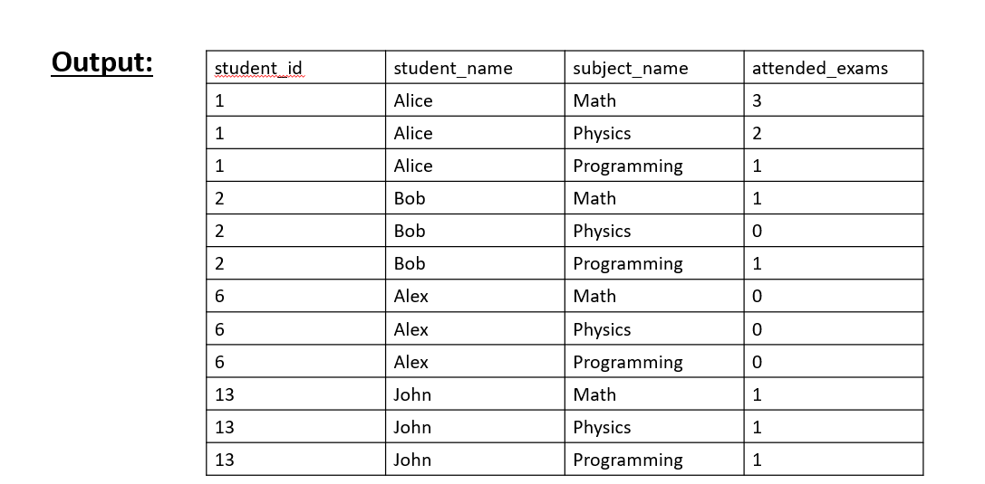

CREATE TABLE Students (
student_id INT PRIMARY KEY,
student_name VARCHAR(50)
);

INSERT INTO Students (student_id, student_name) VALUES
(1, 'Alice'),
(2, 'Bob'),
(13, 'John'),
(6, 'Alex');

CREATE TABLE Subjects (
subject_name VARCHAR(50) PRIMARY KEY
);

INSERT INTO Subjects (subject_name) VALUES
('Math'),
('Physics'),
('Programming');

CREATE TABLE Examinations (
student_id INT,
subject_name VARCHAR(50)
);

INSERT INTO Examinations (student_id, subject_name) VALUES
(1, 'Math'),
(1, 'Physics'),
(1, 'Programming'),
(2, 'Programming'),
(1, 'Physics'),
(1, 'Math'),
(13, 'Math'),
(13, 'Programming'),
(13, 'Physics'),
(2, 'Math'),
(1, 'Math');

Solution 1

WITH CTE1 AS(
SELECT * FROM STUDENTS
CROSS JOIN SUBJECTS
)

--Solution 1
select
st.student_id,
st.student_name,
sb.subject_name,
count(e.student_id) as attended_exams
from Students st
cross join Subjects sb
left join Examinations e
on st.student_id = e.student_id
and sb.subject_name = e.subject_name
group by st.student_id, st.student_name, sb.subject_name
order by st.student_id, sb.subject_name;

Solution 2:

SELECT CTE1.student_id,CTE1.student_name,CTE1.Subject_NAME,sum(CASE WHEN Examinations.student_id IS NOT NULL THEN 1 ELSE 0 END) AS attended_exams FROM CTE1
LEFT JOIN Examinations
ON CTE1.student_id=Examinations.student_id and CTE1.Subject_NAME=Examinations.subject_name
group by CTE1.student_id,CTE1.student_name,CTE1.Subject_NAME

Monthly Transactions
Ques 2 : You are given a table of transactions including:
(1) country
(2) state (approved/declined)
(3) amount
(4) trans_date
For each month (YYYY-MM) and country, you must compute:
=> trans_count → total number of transactions
=>approved_count → number of approved transactions
=> trans_total_amount → sum of all transaction amounts
=> approved_total_amount → sum of approved transaction amounts
Return the results in any order.

Solution:

CREATE TABLE Transactions (
id INT PRIMARY KEY,
country VARCHAR(10),
state VARCHAR(20),
amount INT,
trans_date DATE
);

INSERT INTO Transactions (id, country, state, amount, trans_date) VALUES
(121, 'US', 'approved', 1000, '2018-12-18'),
(122, 'US', 'declined', 2000, '2018-12-19'),
(123, 'US', 'approved', 2000, '2019-01-01'),
(124, 'DE', 'approved', 2000, '2019-01-07');

Approach 1:

SELECT TO_CHAR(trans_date ,'YYYY-MM') as month,
COUNTRY,COUNT(*) AS trans_count,sum(case when state='approved' then 1 else 0 end) as approved_count, sum(amount) as trans_total_amount ,sum(case when state='approved' then amount else 0 end) as approved_total_amount FROM Transactions
GROUP BY MONTH,COUNTRY

Approach 2:

SELECT
TO_CHAR(trans_date, 'YYYY-MM') AS month,
country,
COUNT(*) AS trans_count,
COUNT(*) FILTER (WHERE state = 'approved') AS approved_count,
SUM(amount) AS trans_total_amount,
coalesce(SUM(amount) FILTER (WHERE state = 'approved'),0) AS approved_total_amount
FROM Transactions
GROUP BY month, country;

